**Req# WI001**

The user should not be able to add work experience with same dates range for two companies. An error message pop-up if the user tries to add.

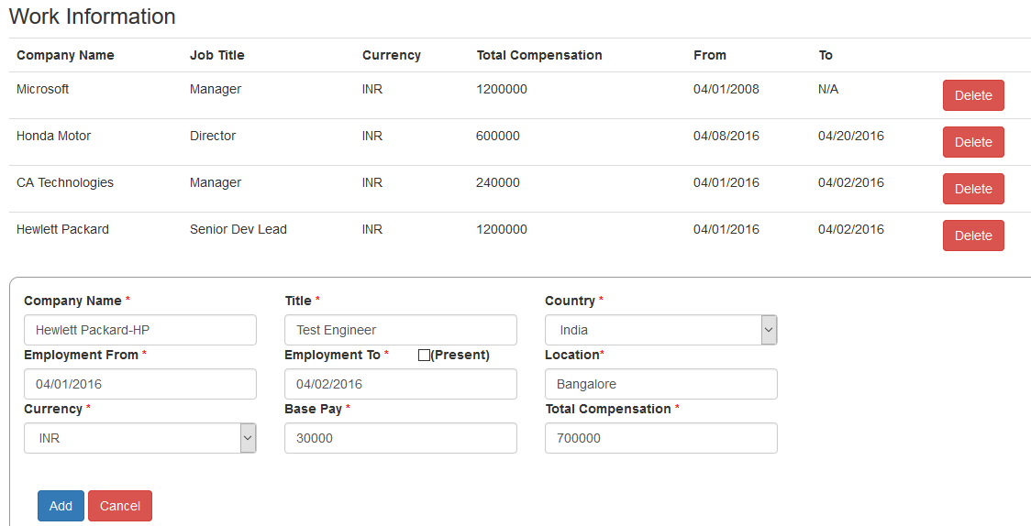

User is not able to input company names having special characters like Amazon.com, Apple Inc., Laing O’Rourke, Hewlett Packard-HP from the auto prompted list or manually. An error message "Please match the requested format" pops up when user clicks on 'Add' button